**Lab 1-3 Query Response**

Name ____Savier Osman____

**Query example SQL code: (list all the current orders and their customers)**

SELECT orders.orderID, customers.customerID, customers.lastName, customers.firstName, orders.orderDate

FROM orders

INNER JOIN customers on orders.customerID = customers.customerID;

**Query example SQL image:**

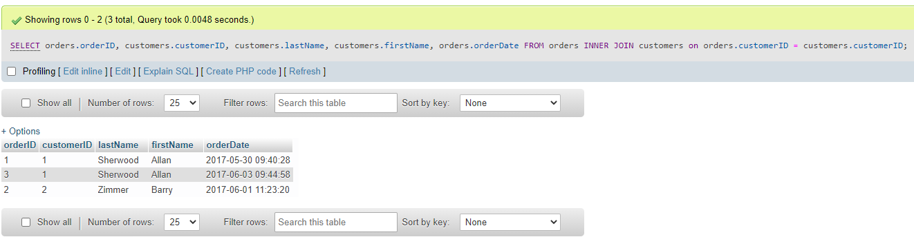

**Query 1 SQL code:**

SELECT orders.orderID, customers.customerID, customers.lastName, orders.orderDate, products.productID, products.productName, orderitems.itemPrice, orderitems.discountAmount, orderitems.quantity

FROM orders

INNER JOIN customers on orders.customerID = customers.customerID

INNER JOIN orderitems on orders.orderID = orderitems.orderID

INNER JOIN products on orderitems.productID = products.productID

WHERE orders.orderID = 3;

**Query 1 Image:**

**Query 2 SQL code:**

UPDATE customers

SET emailAddress = 'asherwood@gmail.com'

WHERE firstName = 'Allan' AND lastName = 'Sherwood';

**Query 2 Image:**

**Query 3 SQL code:**

SELECT SUM((itemPrice - discountAmount) * quantity) AS "Line Item Value"

FROM orders

INNER JOIN orderitems on orders.orderID = orderitems.orderID

WHERE orders.shipDate IS NULL;

**Query 3 Image:**

